Open Requisition Report:
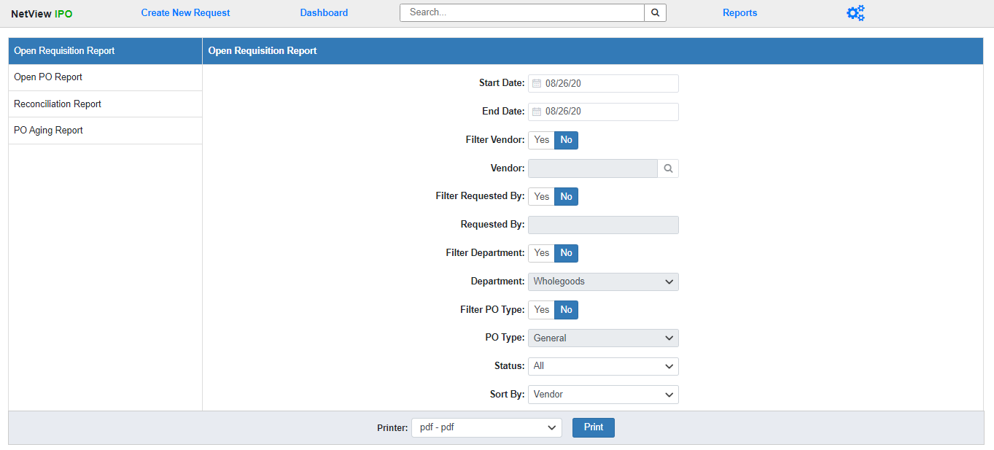

The Open Requisition Report lists all Open Requisitions at your dealer location during a set time period. You can use the fields displayed to run the report for specific items, such as viewing all the Open Requisitions for a single vendor or for a specific Department.

Field Definitions:

Start/End Date: Enter the start and end dates for your desired time period. The report will include all Requisitions that had an Open status during that time period. Both fields default to the current date.

Filter Vendor: Select Yes to run the report for all Open Requisitions belonging to a specific vendor. Select No to run the report for all vendors.

Vendor: This field will activate if you choose to filter the report by vendor. Enter the Vendor Number you wish to run the report for or use the Search option to look it up by entering part or all of the vendor’s name.

Filter Requested By: Select Yes to run the report for all Open Requisitions created by a specific user. Select No to run the report for all creation users.

Requested By: This field will activate if you choose to filter the report by the creation user. Enter the desired user’s ID here. NOTE: If the ID you enter doesn’t exist in the system, you will receive a blank report.

Filter Department: Select Yes to run the report for all Open Requisitions belonging to a specific Department. Select No to run the report for all Departments.

Department: This field will activate if you choose to filter the report by Department. Select the desired department from the drop-down menu. The options will be all Departments that currently exist in your system.

Filter PO Type: Select Yes to run the report for all Open Requisitions with a specific PO Type. Select No to run the report for all PO Types.

PO Type: This field will activate if you choose to filter the report by PO Type. Select the desired type from the drop-down menu: General, Unit, or Part.

Status: Use this field to choose what Open Requisition status you want to run the report for:

- All: Runs the report for all Open Requisitions regardless of status.
- Pending Approval: Runs the report for all Open Requisitions that have been submitted for approval and are waiting to be reviewed by an Approver.
- Not Submitted: Runs the report for all Open Requisitions that have not yet been submitted to become Purchase Orders.

Sort By: Use this field to determine what order the report will show the Open Requisitions in:

- Vendor: Sorts the Requisitions by Vendor Number. This is the default sort order for the report.
- Requested By: Sorts the Requisitions by creation user ID.
- Department: Sorts the Requisitions by Department.
- PO Type: Sorts the Requisitions by PO Type.

Printer: Select the printer to receive the report. Use the pdf printer to view the report before printing.

Click “Print” to run the report.

Sample Report:

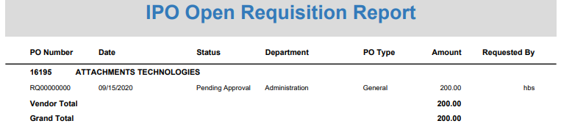

report is divided into sections by vendor, with each section beginning with a line listing the vendor number and name.

Report Columns:

PO Number: This column shows the Open Requisition’s document number.

Date: This column shows the document date.

Status: This column shows the Open Requisition’s status (Pending Approval or Not Submitted).

Department: This column shows the document’s Department.

PO Type: This column shows the Requisition’s PO Type (General, Unit, or Part).

Amount: This column shows the Requisition amount.

Requested by: This column shows the name of the user that created the Requisition.

Vendor Total: A total line for the Amount column appears after the last Requisition entry for each vendor, letting you know the total value of all the vendor’s Open Requisitions.

Grand Total: This line appears at the end of the report and provides the total dollar amount of all Open Requisitions on the report.

